**Boot Camp Setup**

# Objective:

*To install Windows on a Mac using Boot Camp. You will need to have windows to complete certain exercises throughout the semester. All software is free, an alternative is Parallels but it is recommended to use Boot Camp. Using the Google Chrome browser is recommended.*

Table of Contents

Objective: 1

Step-1: 3

Step-2: 4

Step-3: 5

Step-4: 6

Step-5: 7

Step-6: 8

Step-7: 9

Step-8: 10

Step-9: 11

Step-10: 12

Step-11: 13

Step-12: 14

Step-13: 15

Step-14: 16

Step-15: 17

Step-16: 18

NOTES: 19

Step-1: Download a copy of Windows 10 using the link found below:

<https://www.microsoft.com/en-us/software-download/windows10ISO>

Step-2: Navigate to the following link to locate your university copy of Windows 10:

<https://azureforeducation.microsoft.com/devtools>

Login using your netID and password.

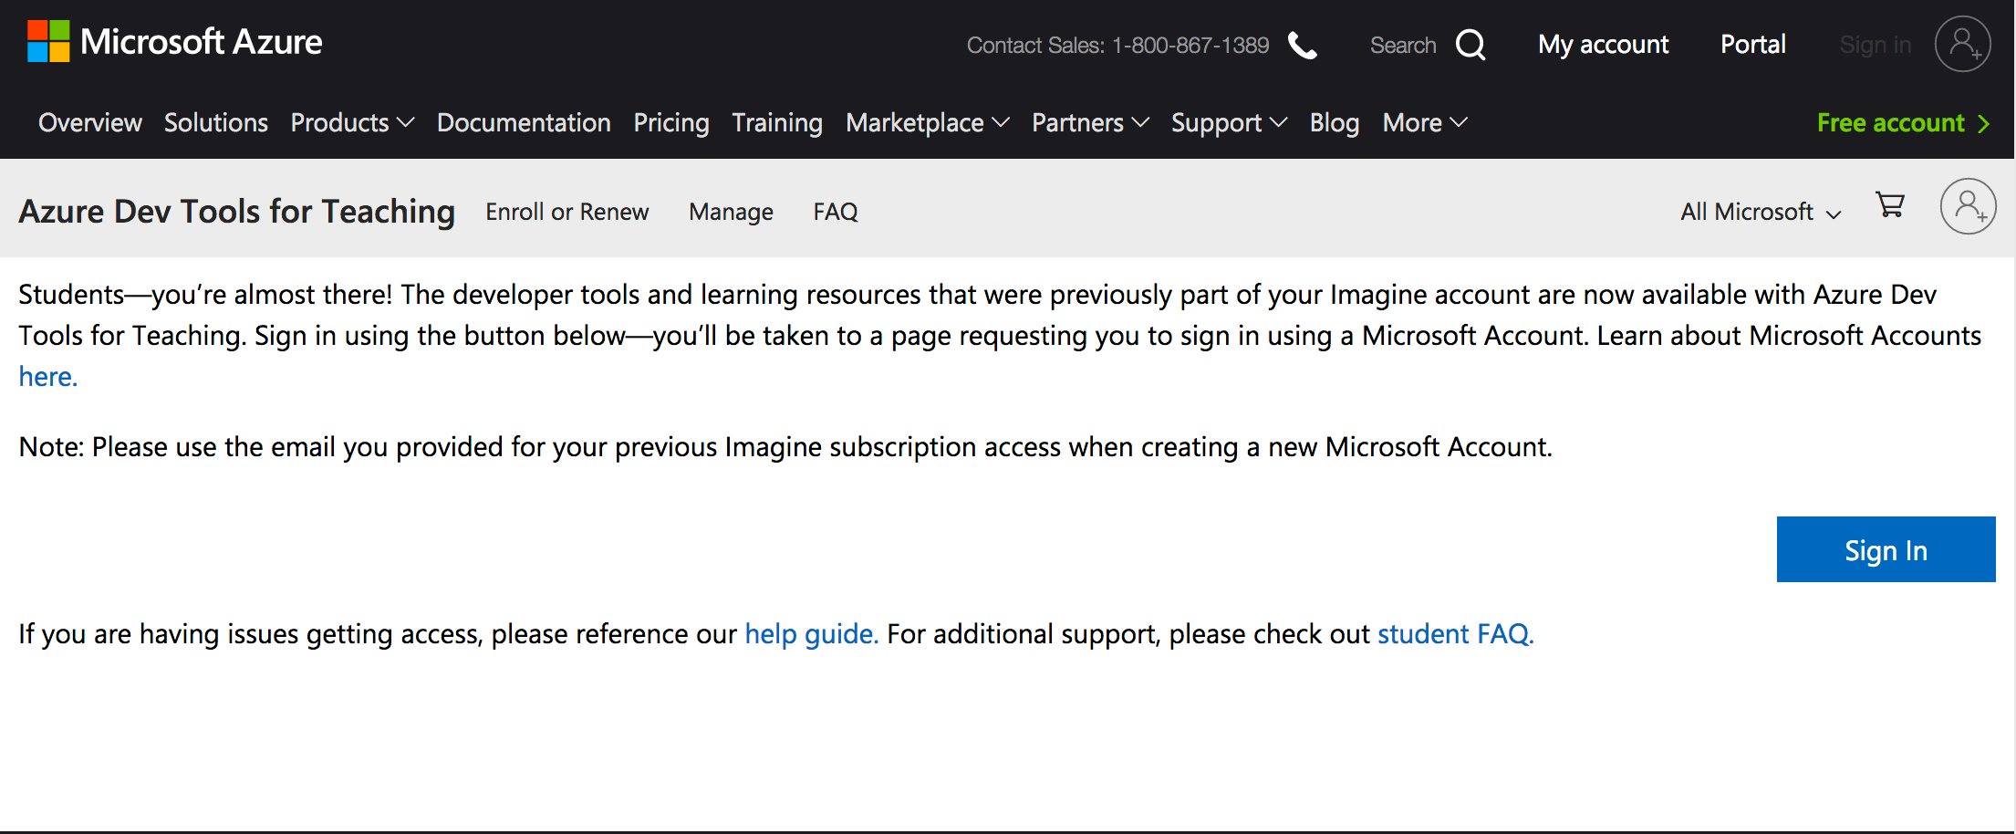

Step-2: After a successful login, click on the software icon. Type “Windows 10” in the search window displayed below.

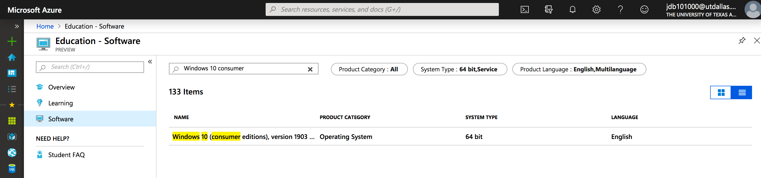

Step-3: Select the Windows 10 Education Version or the closest version to what is displayed. Click on the blue View Key button. Copy or write down your software license key. Click on the blue Download button. Select save file. Review the download process as appropriate for your browser.

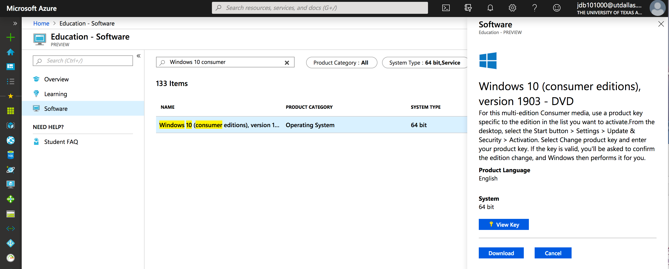

Step-4: Run the Boot Camp Assistant application on your mac. It should already be pre-installed on every mac post 2006.



Step-5: In the next prompt select “continue” till you reach the following page. On this page click “choose” and select the Windows 10 file that you downloaded in step 3, also choose your Boot Camp partition size using the slider. Use the maximum size you can and click on “install”.



Step-6: After installation has been complete, your system will shut down and restart automatically. Make sure to press the “alt/option” while the computer is starting up, you should now see you windows partition available. You should go through the following steps until the Windows desktop appears.

* You will first see a windows setup screen that asks you the following information, enter the information and click next:
  + Language to install: English (United States)
  + Time and currency format: English (United States)
  + Keyboard or input method: US
* In this prompt you are asked to enter the product key. Enter the 16-digit product key you saved from step 5 and click next.
* In this prompt you have to select the operating system, select “Windows 10 Education” and click next.
* In this prompt, accept the license terms and click next.
* In this prompt, you have to select where you want to install Windows. Select the “BOOTCAMP” drive and click next.
* You should now see a prompt that says “Installing Windows”
* In the next few prompts enter the following:
  + Region: United States
  + Keyboard Layout: United States
  + Who is going to use this PC: Your Name
  + Password and Confirm Password: Password of your choice
  + 3 Security Questions
  + Cortana: Yes or NO
* Windows should finish configuring and you should see your desktop.

Step-7: Once the windows desktop starts up, the Boot Camp application should have already started as shown below:

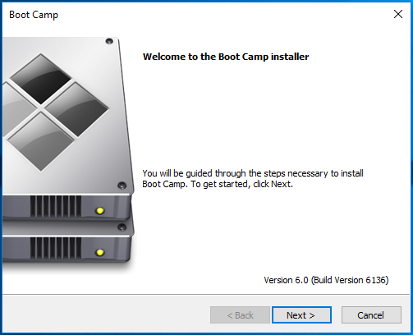

Click next.

Step-8: In the next prompt, accept the terms of the license agreement and click “Install”.

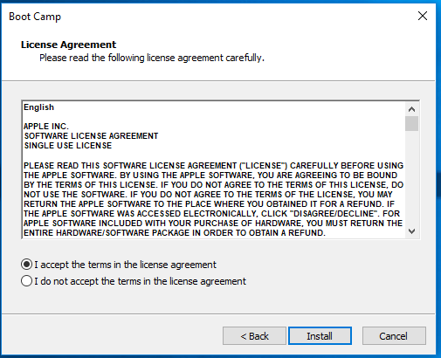

Step-9: You should now see that Boot Camp is installing like shown below:

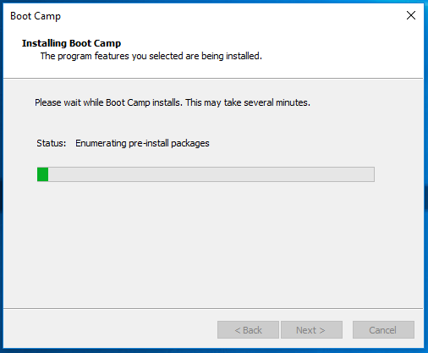

Step-10: Next you should see a prompt that says Boot Camp has been successfully installed. Click on “Finish”.

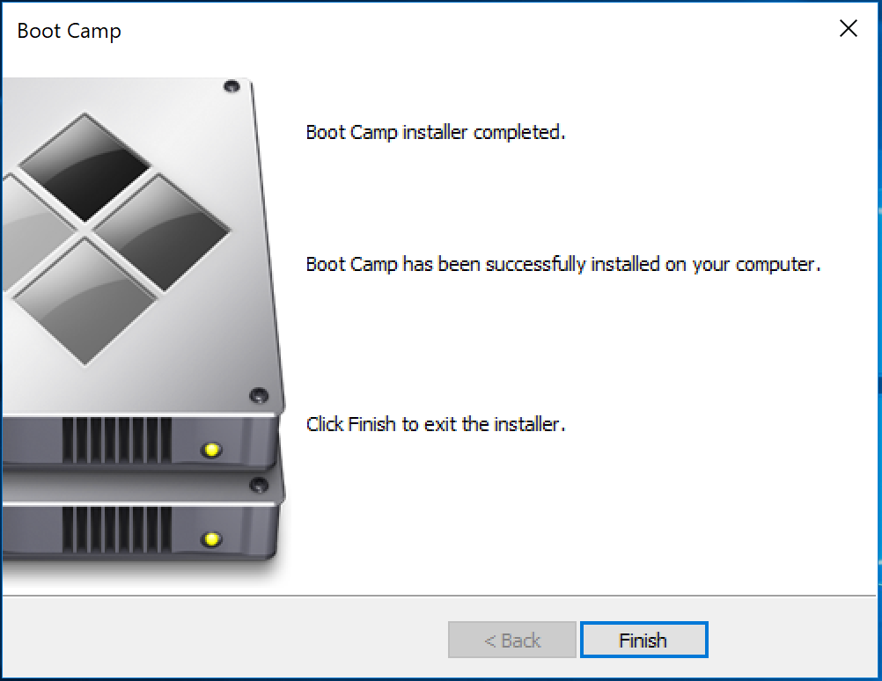

Step-11: Installation has now complete, click “Yes” and restart the system as shown in the window below:

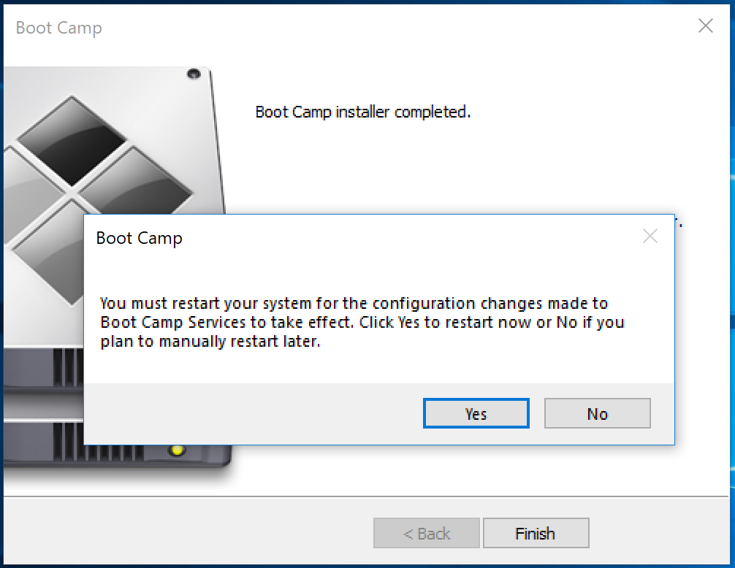

# NOTES:

* Be sure to keep your laptop charged throughout the installation process, it may take a while.
* Boot Camp will take care of setting up your windows environment.
* The product key that was saved in step 3 will be used while setting up your windows partition, make sure to save it.